School of Informatics & Cybersecurity - Assessment Brief Coversheet
General Assessment Information
Module Title: | Computer Vision
Module Code: | COMP H4031
Assessment Title: | Deep Neural Networks in Tensorflow and Keras
Assessment Type: | Practical
Assessment Weighting (%): | 15%
Submission Deadline: | See Brightspace
Late Submission Penalty: | N/A

Use of Generative AI
√ The use of generative AI tools (e.g., ChatGPT, DALL·E, etc.) is NOT permitted for this assessment.
☐ The use of generative AI tools IS permitted under the following conditions:
Conditions and limitations for use:
Level 1: No Artificial Intelligence (AI). The assessment must be completed entirely without AI assistance. AI must not be used at any point during the assessment.

TU Dublin guidelines on responsible use of AI can be downloaded here.

Lecturer Name(s): ______Dr Simon McLoughlin_________________

Computer Vision Assignment 2 (15%)
Deep Neural Networks in Tensorflow and Keras

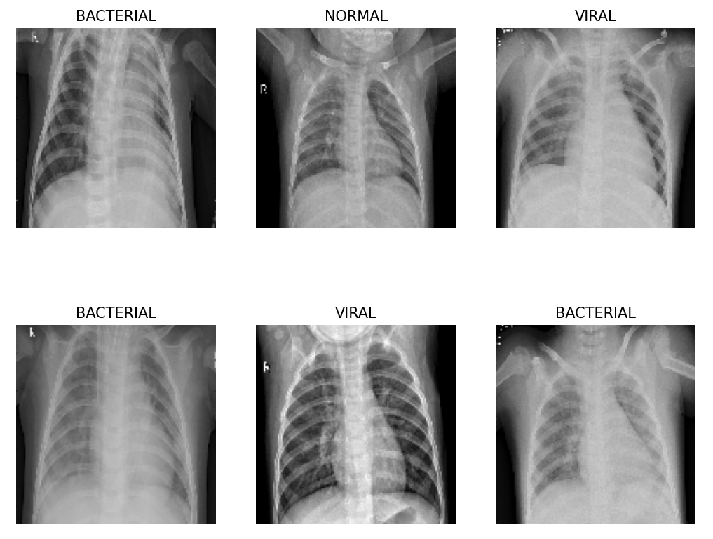
Main Assignment Goal – Maximise classification accuracy, precision and recall as much as possible on the supplied dataset (evaluate on the test set).
The first thing you should do is create a python virtual environment (venv) for your deep learning work. A Python virtual environment is an isolated space where you can work on your Python projects, separately from your system-installed Python. You can set up your own libraries and dependencies without affecting the system Python. See the list of steps below to set this up.
- Pick a directory on your hard drive that you want your python virtual environments to be located in.
- Open a command prompt and change into that directory.
- Now enter the command (on Windows): ‘py -m venv <venv_name> ‘ where <venv_name> is the name you choose for the virtual environment
- Now you need to update the venv with the latest version of python (tensorflow needs version 3.8+): ‘python -m venv --upgrade <venv_name>’
- Now you need to activate the virtual environment: ‘<venv_name>\Scripts\activate’. To deactivate the venv type: ‘deactivate’ at the cmd prompt.
- Now you can install tensorflow and keras with the following command: ‘pip install tensorflow’
- You may need to install matplotlib too: ‘pip install matplotlib’
- Now you should be able to navigate to the folder where your python script is and run it: ‘python myscript.py’
Once you are setup and ready to go download the two .py files that are on Moodle/Brightspace (mnist_classification.py and pneumonia_classification.py) and store them in a local directory. Verify your tensorflow installation is working correctly by running the mnist classification example. This is a very simple keras example that performs classification on the mnist datatset (handwritten digitis). Once verified download the chest xray dataset from the following link:
https://drive.google.com/file/d/1lP9l3FBNNmWJD7q69v9Bnf4TMDxay_tx/view?usp=sharing
Extract this dataset somewhere appropriate on your hard drive (you will need 1.1 GB for it). Now modify the pneumonia_classification script to include the path of the directory to the extracted image data. Browse through the directory structure and look at some of the images.
Now you should be in a position to execute the pneumonia_classification.py script. It should produce an output as follows:
You will see the progress of the neural network training phase. Depending on your PC this can take a few minutes but it should not take more than this.
For this assignment you are required to improve the validation and test scores of the network performing pneumonia classification. This will involve some research on your behalf. In particular answer the following questions?
- How long did the network take to train?
- Is the dataset balanced? What is the distribution? If not can I do anything to address this?
- Is the network overfitting? Why or why not? If so what can I do to address this, see GlobalAveragePooling2D ?
- Can you perform any data augmentation?
- What layers are in the network? Can I alter anything here to improve matters? Perhaps take a look at the keras tuner (https://www.tensorflow.org/tutorials/keras/keras_tuner)
- Is transfer learning an option here using a pre-trained model?
- What are the per class precision, recall and F1 scores? What do they mean and which is best here.
- How might you make the model better at finding the sick patients?
- Is it possible to see what the CNN is seeing? Can I use tf-explain (e.g.GradCam) to see this?
- Anything else that you come across in your research to improve the model.
For this assessment you should submit the following:
- Your updated python script or a Jupyter notebook (preferred) performing the chest xray classification and a link to your Github repo showing all your commits.
- A report detailing your trials, tribulations and findings.

